Jake Traut

3/14/2016

CSCI 3656 Problem Set 8

1. Xfig drawings.

Smooth figure eight tool. Based on the placement and ordering of vertexes and the output from this drawing tool, I would have to say this one uses B splines. My reasoning follows from the fact that the splines don’t go through all the points, which in this case are control points. And the drawing also stays within the convex hull of the points.

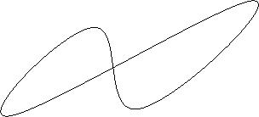

Figure eight tool with superimposed dots. My intuition tells me this tool uses cubic natural splines, for multiple reasons. First, the splines hit all points. Second, the points here are data points rather than control points. Third, the generated splines don’t necessarily stay within the convex hull (the curves extend out). Lastly, playing with the move point tool creates global effects rather than local changes.

